**Battle of the Neighborhood Project**

Richard Min

1. Introduction:

New York City is very diverse in their culture and cuisine. I want to pitch to investors who are interested in opening up a sushi restaurant in New York City and I want to find the most optimal location to start this new business venture. My target audience will be investors who are interested in opening up a sushi restaurant in New York City. I feel that Japanese cuisine is getting more popular in the United States and that New York City would be a great location to start a restaurant since there seems to be a lot of Michelin star restaurants in that area.

1. Data: <https://geo.nyu.edu/catalog/nyu_2451_34572>.

In this dataset about New York City, there are 5 different boroughs that contain 306 different neighborhoods. This dataset also gives the longitude and latitude coordinates of each neighborhood.

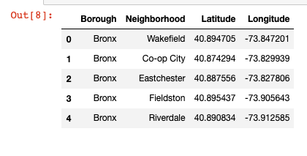

Using Foursquare, I was able to find sushi restaurants in New York City and their ratings. With the Foursquare API, I found the closest venues for each borough and the 10 ten common venues that people went to.

1. Methodology:

I first tried to visualize the amount of neighborhoods in each borough

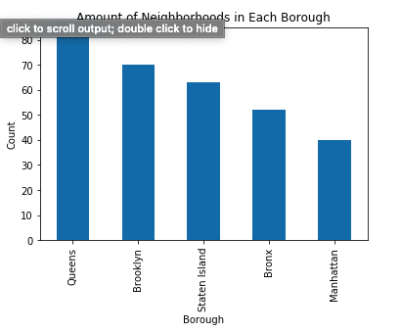

Then I created a map of New York City with all the neighborhoods indicated.

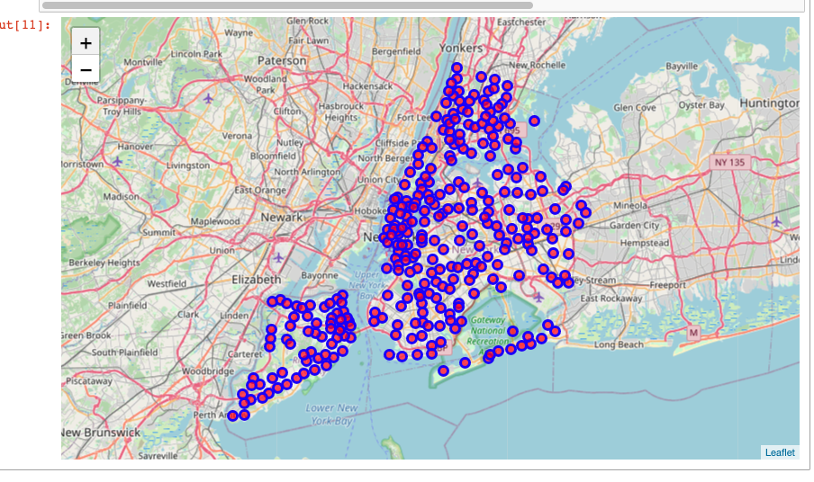

I created a dataset to find the different sushi restaurants in New York City and then used Foursquare API to find the ratings, likes, and the amount of tips each sushi restaurant had. With this information I then created a different dataset to include all the new data collected. I created a bar graph to visualize the amount of sushi restaurants in each NYC borough.

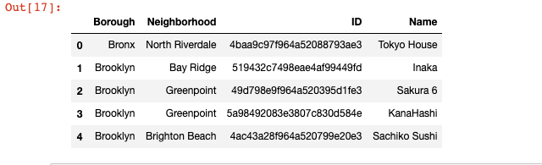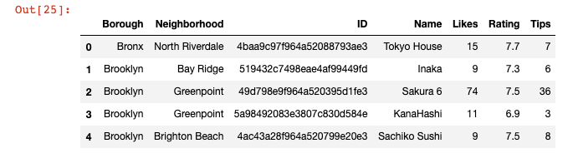

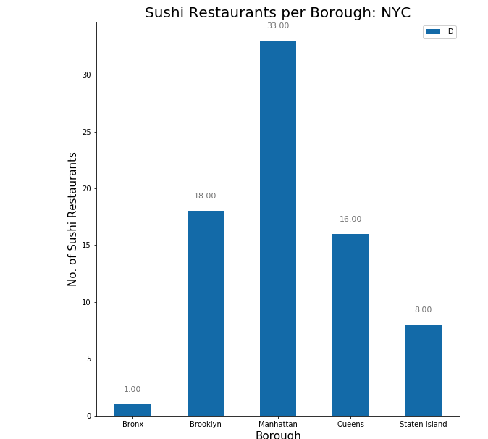

After, I found the average rating of sushi restaurants of each borough to find which borough had the best sushi to offer; I also made another bar graph to visualize this.

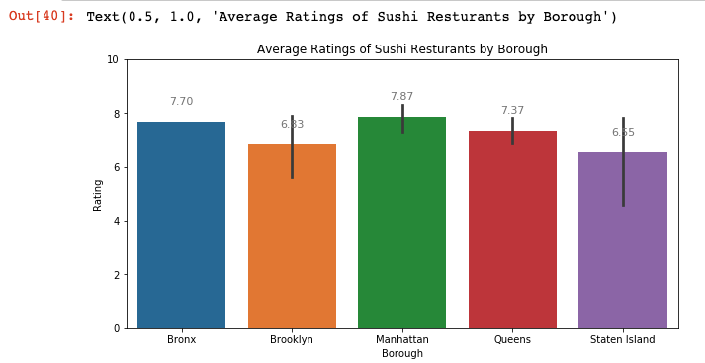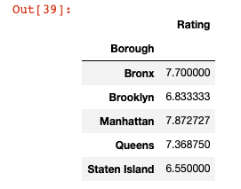

I found the average rating of each sushi restaurant for each neighborhood and made another dataframe to find neighborhoods with the average rating over 8 to find the best places to get sushi. Then I created a dataframe that had all the sushi restaurants that were in the top neighborhoods for sushi.

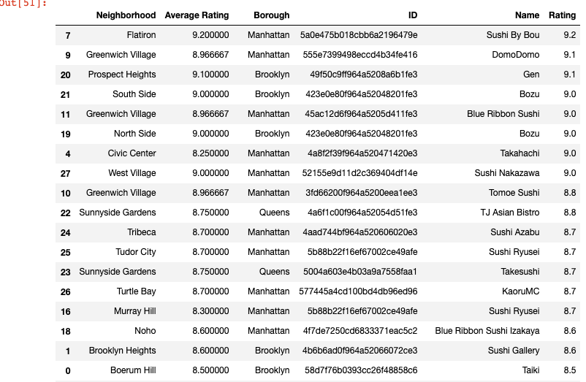

From looking at the table above I saw that Manhattan had the best sushi restaurants and I used unsupervised machine learning algorithm K-mean clustering to create clusters of 5 in Manhattan to figure out the best neighborhoods of Manhattan to start a new sushi restaurant.

First created a map of Manhattan and the different neighborhoods:

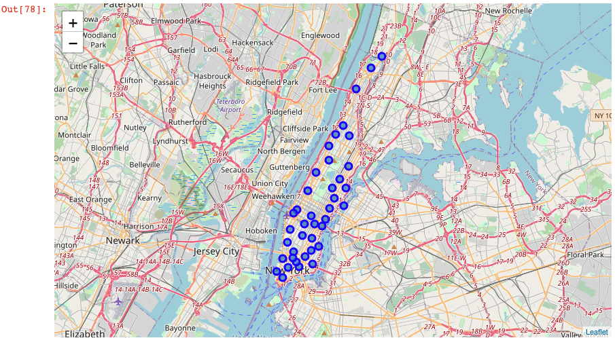

Then I created the same map as above but with each neighborhood in the colors of the cluster they were in. 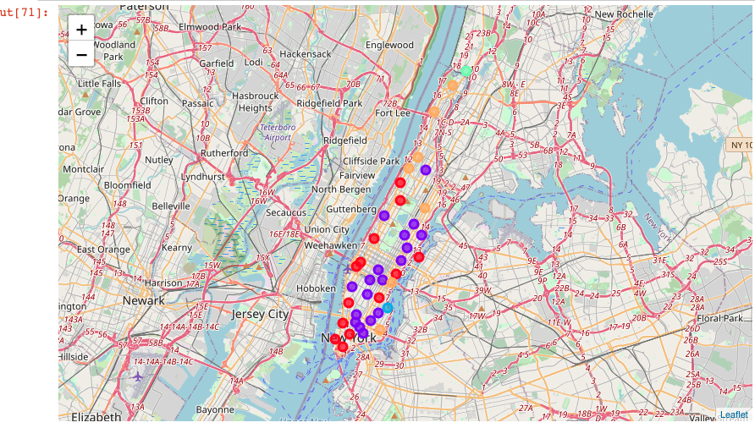

Python Packages Used:

1. Pandas: library for data analysis
2. NumPy: library to handle data in a vectorized manner
3. Seaborn: library for data visualization
4. Json: library to handle JSON files
5. Sklearn: library for Python Machine learning
6. GeoPy: location data
7. Folium: library for rendering maps
8. Request: library to handle https requests

IV. Results:

I found out that the neighborhood Flatiron had the best overall rated sushi restaurant called Sushi by Bou with a score of 9.2 in the Manhattan borough. In fact, from the top average rated sushi restaurants, most of them are found in Manhattan with 18.

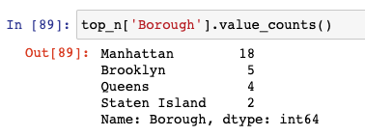

With the Foursquare API, I found the most common venues for each neighborhood and selected the top 10 most common ones for all the neighborhoods in each cluster. Analyzing the different clusters, it seems that the best clusters 1 and 4 seem to be the best place to start any restaurant since the most common venues seem to be different ethnic restaurants. These areas where clusters 1 and 4 are could be a great opportunity to start a sushi restaurant.

V. Discussion:

There are 306 different neighborhoods in New York City with each belonging to one of the 5 boroughs: Manhattan, Staten Island, Brooklyn, and Queens. Interesting to see that Manhattan not only has the top rated sushi restaurants, but also has the most sushi restaurants compared to other boroughs with Brooklyn coming close. There is only one sushi restaurant in the Bronx.

VI. Conclusion:

In conclusion, the best area to open a sushi restaurant would be Manhattan, New York. In that area, most of the top rated sushi restaurants are located and it is known to be an area of fine cuisine. Not only is there a lot of restaurants in Manhattan, there are a lot of other venues that people can visit so that there are always people in that area, leading to more potential customers.